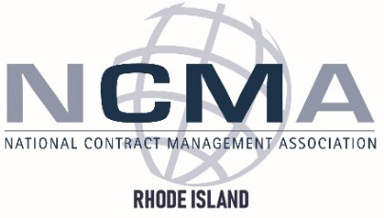
Event Rescheduled for January 27, 2026
Updated Agenda TBA
Ocean State Workshop Agenda
Tuesday October 21, 2025
Newport Officers’ Club

0730 Check-In & Networking

0830 Welcome/ Introductory Remarks Mr. Alexander Hayden | NCMA RI President

0845 USW & Great Power Conflict – Dr. Erik Sand | US Naval War College
The Uncommanded Sea

0945 Mastery of the Seas – NUWC Mr. Steve O’Grady
Strategy Connection to Wartime Dept. Technical Director, NUWCDIVNPT
Readiness Planning (WARP)

1030 Networking Break

1045 WARP – Command Perspective CAPT Kevin Behm
+ Recent Lessons Learned Commanding Officer, NUWCDIVNPT
Ms. Aimee Racine
Branch Head, C2514 – Combat Systems Dept.

1115 WARP at NUWC + Mr. Andrew Nagelhout
Top Impact Items & Challenges NUWCDIVNPT, Code 02

1215 Lunch

1300 Industry Impacts and Preparation TBA – Industry Panel

1400 Networking Break

1415 Collaborative Training Exercise Breakout Groups

1530 NUWC Small Business Office Ms. Maria Gregory
Announcements NUWCDIVNPT, Small Business Director

1600 Social

